EXPERIMENT:12

Demonstrate Infrastructure as a Service (IaaS) by creating a resources group using a Public Cloud Service Provider (Azure), configured with minimum CPU, RAM, and Storage.

STEP1: FIRST, OPEN AZURE THEN GO THE CREATE AND THEN FILL IN THE BASICS.

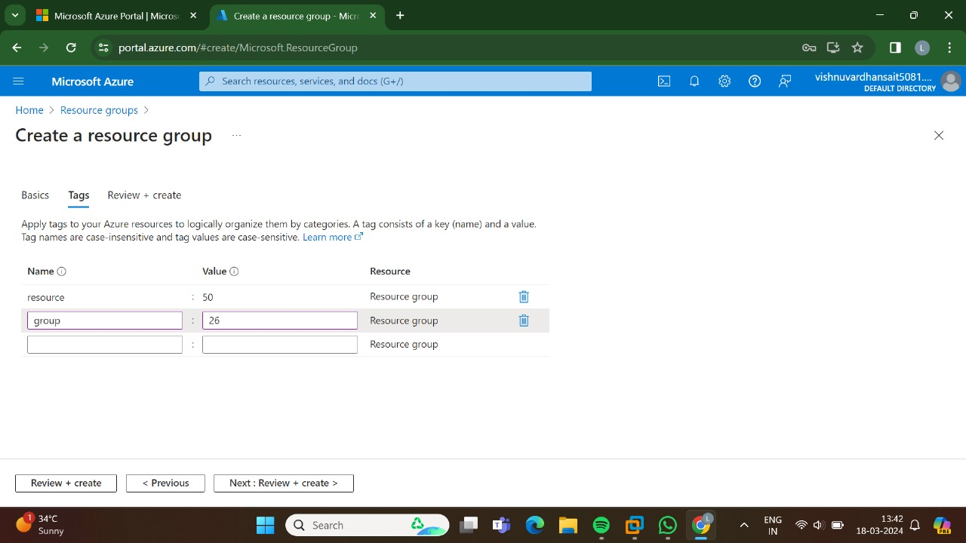

STEP 2: AND THEN NEXT GO TO THE TAGS.

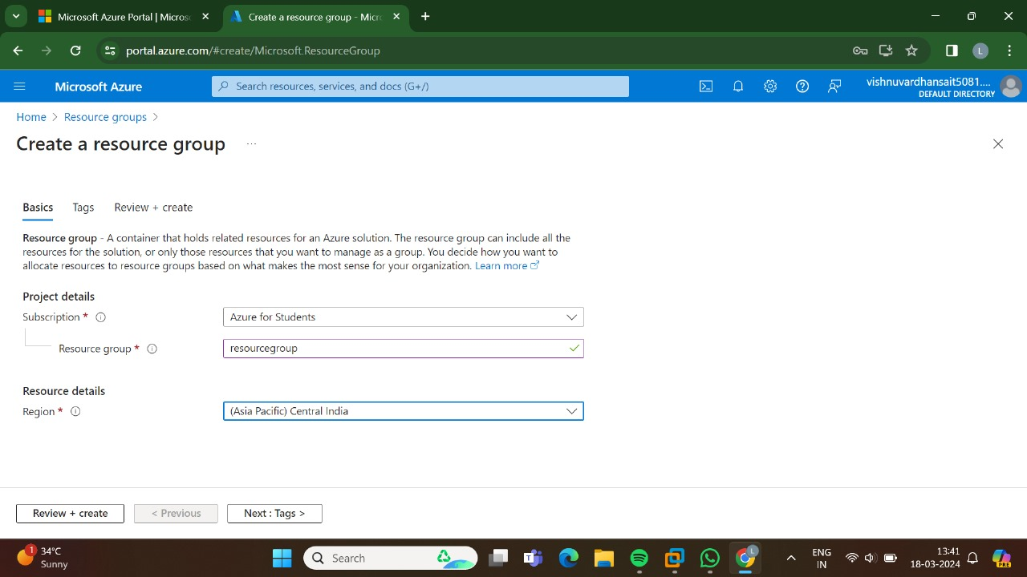

STEP 3:: AND THEN ATLAST GO TO THE REVIEW +CREATE AFTER CLICKING THIS THE VA;IDATION WILL BE SUCCESSFUL.

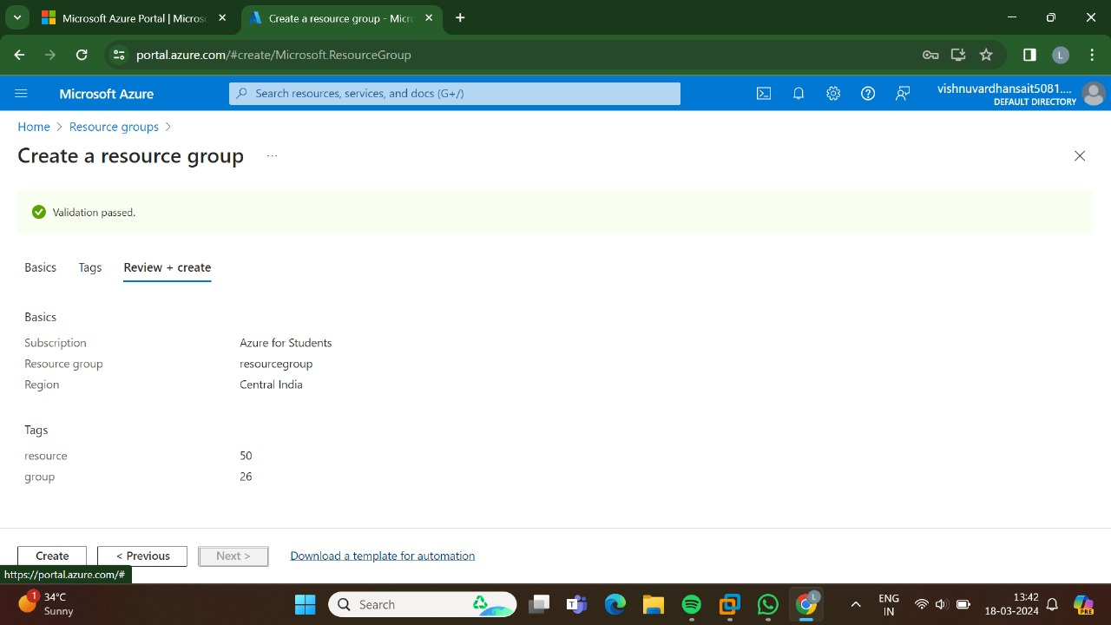

STEP:4: HENCE,HERE IS THE OUTPUT FOR THE RESOURCE LAYER IN AZURE.

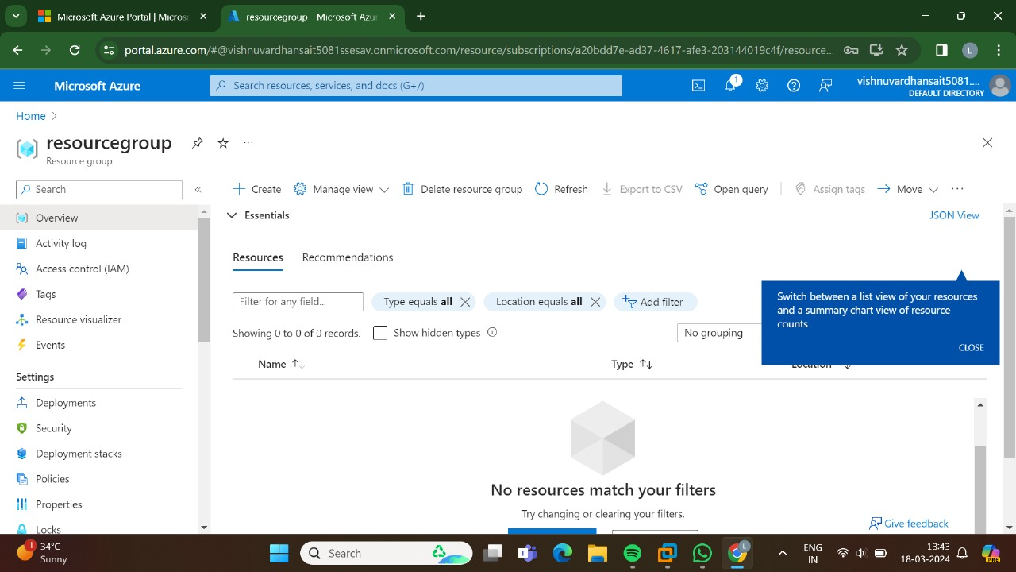

RESULT: THUS,THE PROGRAM FOR THE RESOURCE GROUP IN AZURE HAS BEEN DONE SUCCESSFULLY.